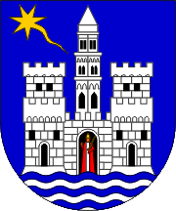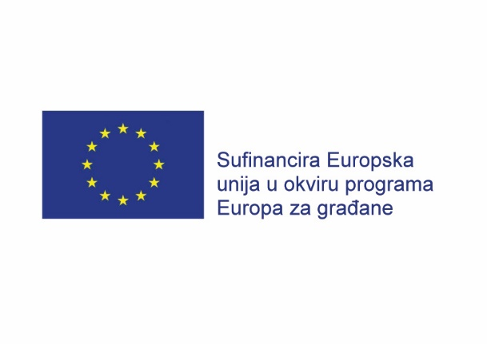

City of Trogir
Trg Ivana Pavla II br. 1/II "With the support of the Europe for Citizens
Croatia programme of the European Union"

„ EUROPEAN DEMOCRATIC ENGAGEMENT AND CIVIC PARTICIPATION CONFERENCE OF TWINNED TOWNS - EURODEM „
3 – 8 of September 2015
City of Trogir, Croatia

Project partners: City of Trogir ( Croatia ), Prague -5 ( Czech ), Budapest 11 – Ujbuda ( Hungary ), Vaterstetten ( Germany )

In line with annual priorities of the " Europe for citizens " Programme City of Trogir will organize a conference with above mentioned partner towns from September 3 - 8 2015, with the support of the Europe for Citizens programme of the European Union.The conference will put specific attention to the promotion of democratic engagement and civic participation and presentation of that area as an essential element in building active European citizenship. Through the promotion of democratic engagement EURODEM conference aims at creating the platform for future exchange of experiences and intercultural cooperation among project partners and European citizens in large with the specific goals to enable environment for the promotion of civic participation in the EU, empower organisations in that area and raise awareness of the importance of that activities . EURODEM will be focused on exchanging best practices and experience related to promotion of democratic participation at Union level, the need to raise public awareness about importance of democratic engagement and civic participation at Union level. EURODEM will include about 230 participants. Event will be broadly promoted in each country and broader with the goal to increase public awareness and citizen’s participation in the area of democratic engagement. Expected results are the following: established twinned cities network, developed a platform for exchange of experience and best practices of democratic engagement in Europe, increased knowledge about more effective civic animation management, increased importance about the twinned cities cooperation. A long-term cooperation and a network of partners will be established trough signed memorandums at the event. Partners will define priorities for future joint projects aimed at improving activities in area of democratic engagement and civic participation and making active dialogue between experts and citizens.

General objectives:

- To foster European citizenship and to improve conditions for civic and democratic participation at Union level.

Specific aims:
- Encourage democratic and civic participation of citizens at Union level, by developing citizens' understanding of the Union policy making-process and promoting opportunities for societal and intercultural engagement and volunteering at Union level.

Through conference related to promotion democratic engagement and civic participation, the project EURODEM will create connections within EU members and give them opportunity to learn from each others experience by exchanging best practice examples and dissemination to citizens thru active participation. The project is in line with the following general programme objectives: „ To foster European citizenship and to improve conditions for civic and democratic participation at Union level „. Project is also in line with specific aims: „ Encourage democratic and civic participation of citizens at Union level, by developing citizens understanding of the Union policy making – process and promoting opportunities for societal and intercultural engagement and volunteering at Union level „. Thru project activities partners will exchange know-how and experiences related to the promotion democratic engagement and civic participation. EURODEM will create a platform for participation and cooperation of experts, associations and citizens. All partners have similar challenges and EURODEM will provide unique opportunity for dissemination of knowledge, developing a long lasting network among twinned cities as well as common future plans of action.
The project is in line with the priorities „Citizens' participation in the democratic life of the EU„ and „The future of Europe “. Important project themes are Inter-cultural dialogue, democratic participation and Active European Citizenship. EURODEM will present to citizens similarities and differences of each partner cities, as well as their challenges and positive practices related to promotion democratic engagement and civic participation. By using the best practice examples, participants and citizens will learn about importance of their active involvement and will raise awareness about of the need to improve democratic engagement and civic participation. EURODEM will stimulate dialogue between professionals and citizens about democratic and civic participation at Union level.

The project is in line with the following features: " Equal access " - through the common, formal and informal activities which will take place at conference in city of Trogir, project will be accessible to all citizens without any form of discrimination and project promoters will promote equal opportunities for all and non-discrimination, „ Transnationality and local dimension „ – this project goes beyond a national vision with purpose to citizens can best be experienced because EURODEM project will be developed and implemented through the cooperation of a partners organizations coming from different participating countries and also project will be targeted directly to a public from different countries reaching a European audience. Regarding of quality of activities thru project specially targeted horizontal feature is also „ Intercultural dialogue „ because through the project activities will be promoted mutual understanding and tolerance, thereby contributing to the development of a respectful, dynamic and multifacted European identity because thru this project participants of different nationalities will participate in common activities. EURODEM project is in line with feature „ Volunteering – expression of active European citizenship „ - through the cross- border dissemination European citizens will learn about importance of volunteering engagement in this area.

EURODEM conference will include about 230 active participants from partner towns. Partner towns will present examples of best practices and share their experiences (both positive cases and challenges) with other partners in area of democratic engagement and civic participation. Each group will prepare their project proposals for future common cooperation based on presented experience and activities organized at conference in city of Trogir. This model has proven to be the best way to exchange know-how and good practices. Conference in city of Trogir will consist of different interactive activities such as presentations, sessions, panels, discussions, and workshops.

a) Through the PRESENTATIONS partner towns will present their experience, best practices and challenges related to democratic engagement and civic participation. They will also educate participants about importance of active citizenship involvement in the area of democratic engagement and civic participation.

b) Through DISCCUSIONS and interactive dialogue participants will talk about different problems and possible solutions more specifically related to each partner town related to effective citizens animation in field of democratic engagement and civic participation.

c) SESSIONS AND PANELS will include lectures of experts with the aim to educate participants about active citizenship and the need to become more actively engaged as volunteers in democratic engagement and civic participation and overcoming obstacles in that area.

d) Through WORKSHOPS participants will together consider and develop possible activities about democratic engagement and civic participation in these towns.

One of the most important segment of EURODEM conference is AWARENESS CAMPAIGN which ensures that target groups are informed of the benefits and challenges related to the democratic engagement and civic participation, the need to develop a sense of European identity, based on common values, history, culture and intercultural dialogue. In EURODEM conference besides the key target group-there citizens in general, there will be also representatives of local, regional and national associations and institutions, universities, Ministry representatives and media representatives. All partners will participate at event. Through the conference, stakeholders will gain proper information on cultural and linguistic diversity between citizens and they will be better informed on opportunities for societal and intercultural engagement and volunteering at Union level. This project has European dimension because participants are from different countries and project results will be disseminated to a public from different countries reaching a European audience.

THE MEMORANDUMS ON FUTURE COOPERATION will assure project sustainability. The memorandum will serve as a tool for the " Democratic engagement and civic participation ". It will provide a description of common problems and identify different solutions to currently issues.

